Width over time analysis program user’s documentation
RESEARCH of ICE CREAM HOMOGENITY AND REGULATED DISPENSE
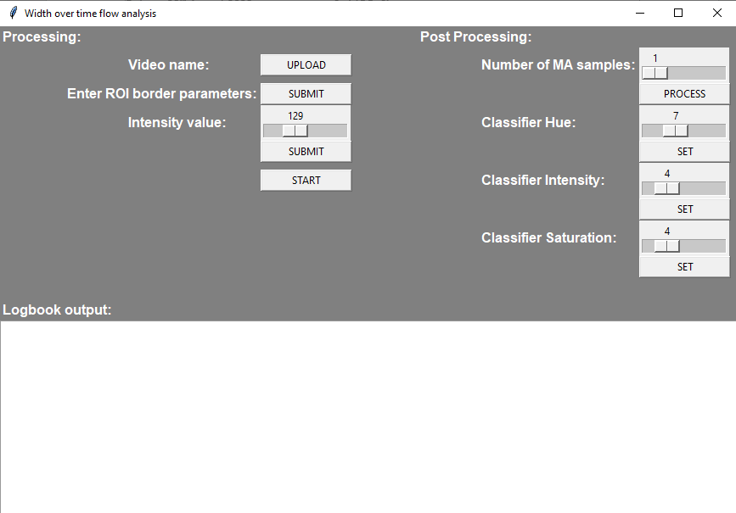
Once you open the .exe file, the interface window will pop up. The interface will look like the picture depicted above. Before analysing, the program needs to receive the position of the video file within the directory system, the desired parameters for the canny edge detector and the geometric data of the region of interest (aka: ROI).
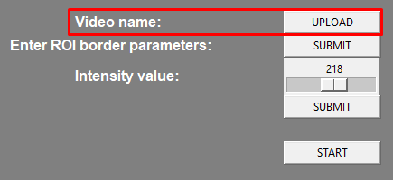
First, give the path of the video. As soon as you click on the “UPLOAD” button, the file explorer is being opened. Go to the file location and open it.
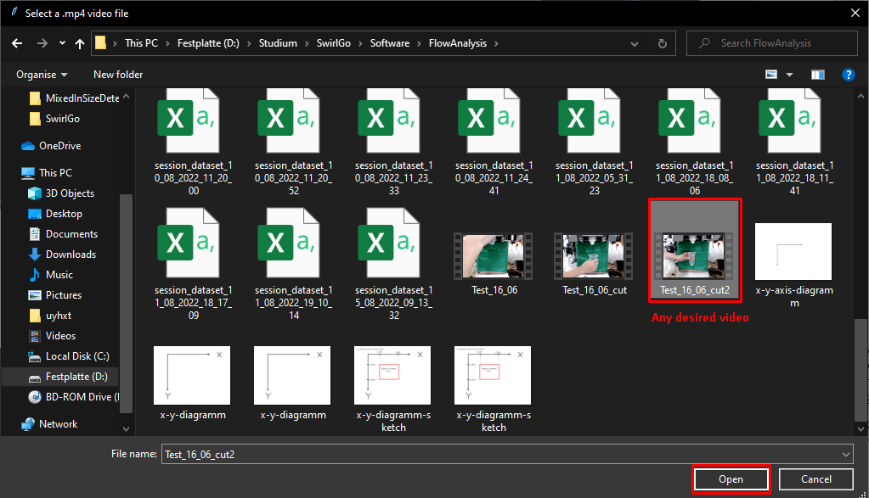
If the upload was successful, you will receive a message in the “Logbook output” text field, that looks like this:
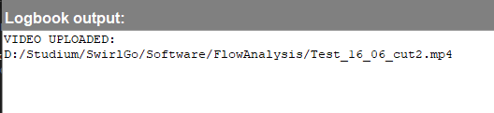
After uploading the video, give the program the information, which region of the video is important for the analysis. Only this region will be analysed later.
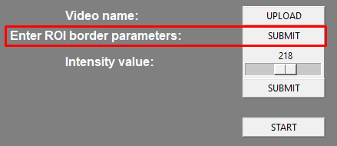
The first frame of the video will be opened. To draw the region of interest, click on the frame with a left mouse button press and drag the region out from the top right corner to the bottom left corner.
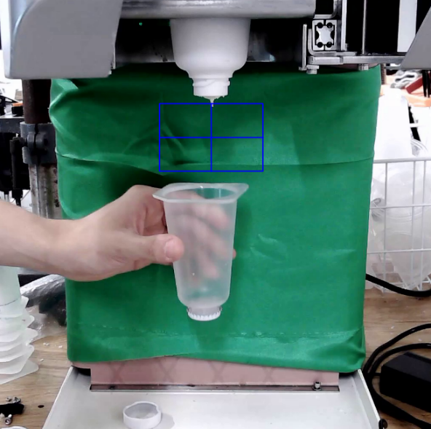
You can resize the ROI the same way, if you are not satisfied with it. To confirm the region of interest size, press the “Enter” key on your keyboard and close the picture window. You will see feedback in the logbook output window if everything went right.
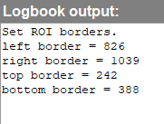
Finally, chose the intensity value for the edge detector. The higher the value, the stronger the contrast within the ROI has to be, to detect something as an edge (e.g. border of an object). The lower the value, the more edges the detector will detect, because it sees lower contrasts as borders, too.
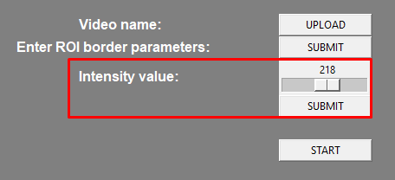
Usually, a value of 200 is recommended. Press the “SUBMIT” button to confirm the selection.
If all steps before worked, start the analysis by pressing the “START” button. A window will open, showing the ROI and the detected edges. The result should ideally look like this:
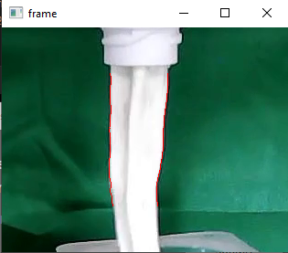
To stop the analysis and get the output immediately, press the button “Q” on your keyboard. A graph will be put out, showing the width of the flow over time. The y-Axis is scaled in pixels. To get accurate results, the resolution of the flow within the ROI needs to be good enough.
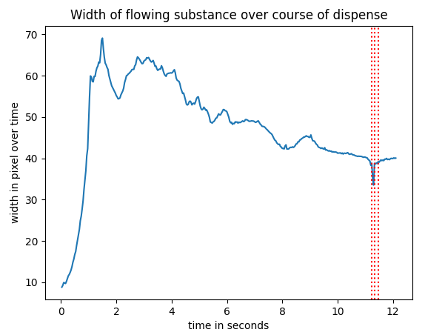
The plot will look similar to this. The red dotted lines show the points in time where the flow broke off. After closing this graph, a second graph will be shown. It is a plot of the flow’s hue over time. The y-Axis is scaled in degrees [0°-360°].
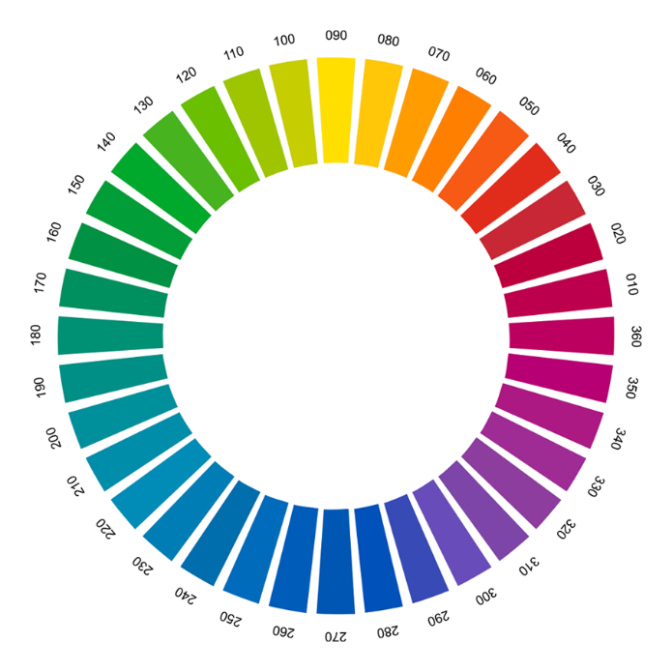
The hue can be represented with a colour wheel. The larger the difference in degree, the further two colours are set apart.
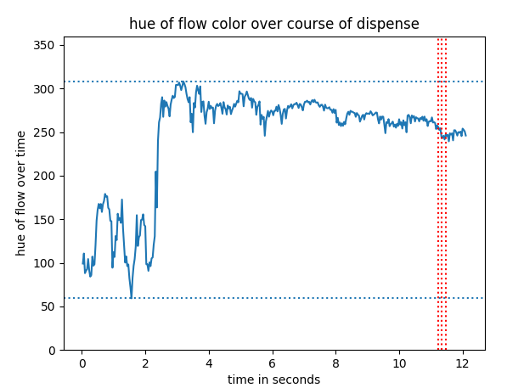
The graph will look somewhat like this. The highest and lowest value are being marked by the blue dotted horizontal lines. The larger the range, the worse the performance of the mixing of the mixed- ins is uneven. The slimmer the range is, the more successful the mixing process was.
More precise information is being plotted in the “Logbook output” window. It yields information such as the average, median, maximum, minimum and variance of the analysed plots.
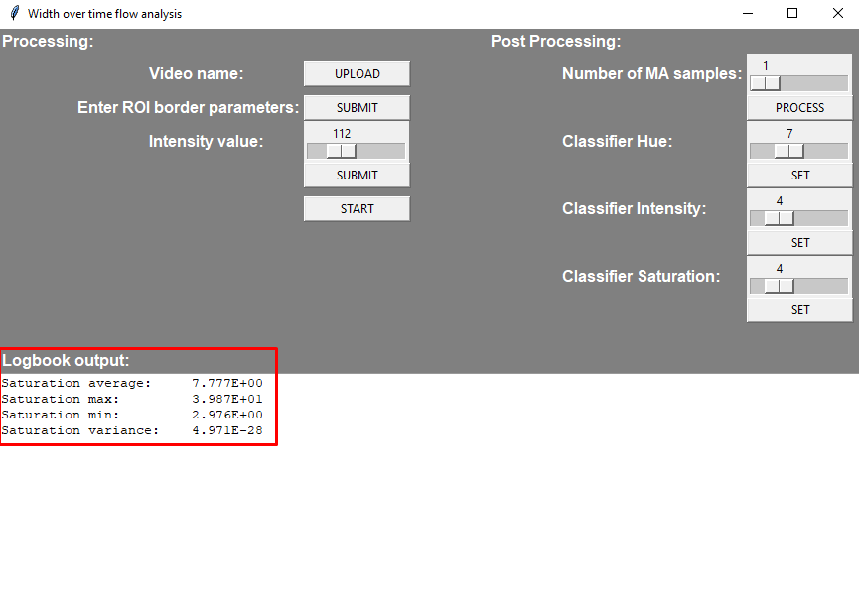
Use the “post processing” part of the program to clear out any major white noise. Adjust the number of MA samples slider. The higher the number, the smoother the graph will become. However, if the number is too high, the graph will become distorted. A recommended value is between 10 and 50 samples. Only in some situations, you will need to go higher.
Press the “PROCESS” button to get the results of the post processing.
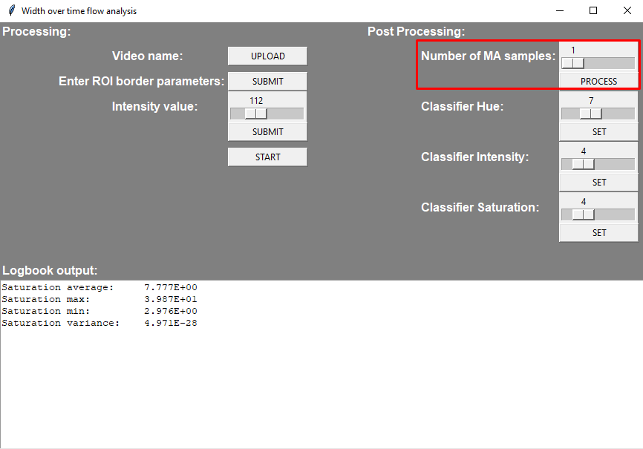
A graph will be shown, plotting the white noise filtered width over time. The left graph is the filtered graph. To compare, the right graph is the original graph.
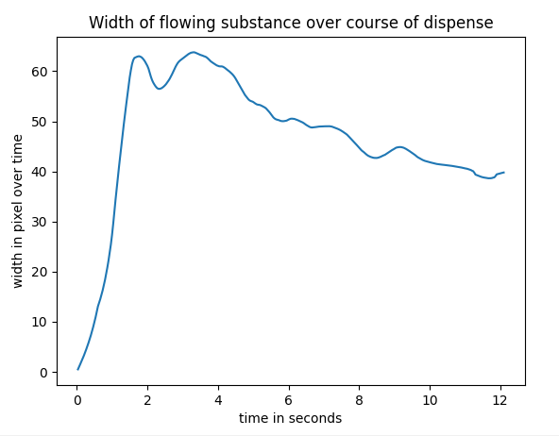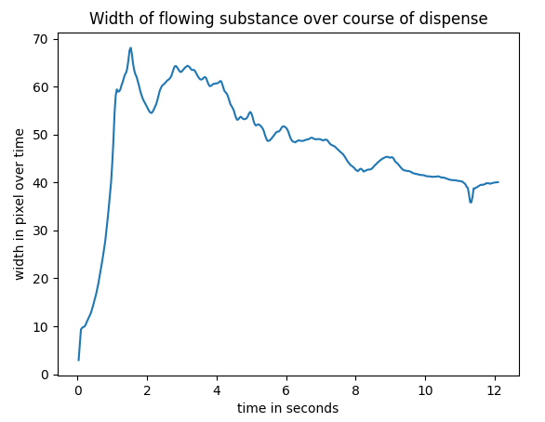
As soon as you close this graph, the graph for the hue over time will be shown. Two graphs can be seen within the plot. The blue graph shows the smoothened graph of the hue. The blue dotted, horizontal lines again show the maximum and minimum of the curve. The red graph represents an approximation of the blue graph. It is used to filter out any remaining white noise from within the blue graph, without having to distort the graph when filtering. The red dotted lines show the maximum and minimum of the approximated curve. The range will usually be narrower or close to equal to the blue curve’s range, since smaller spikes are being filtered out.
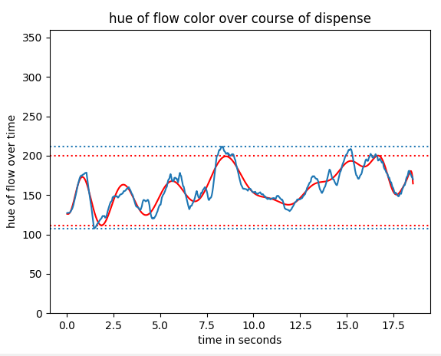
Additionally, you can find precise information about the graphs in the text fields of the post processing part. The fields on the left have information about the blue curve, while the fields on the right give information about the approximated curve.
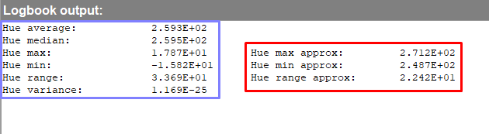
These values give a metric to evaluate the quality of the flow. For both lines, you will generally want two things:
- Hue Variance should be small as possible, ideally 0
- Range should be small as possible, also ideally 0
Furthermore, the user can adjust the sensitivity of the colour classifier. The higher the value, the less classes the classifier will detect. The lower the values, the more colours the classifier will divide the hue, value and saturation graphs into.
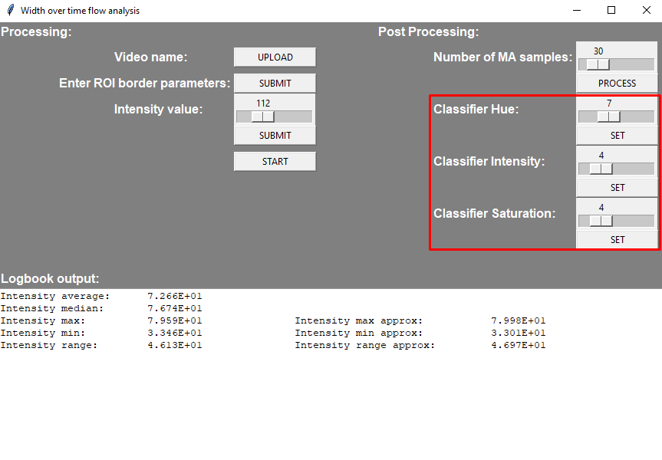
An example:
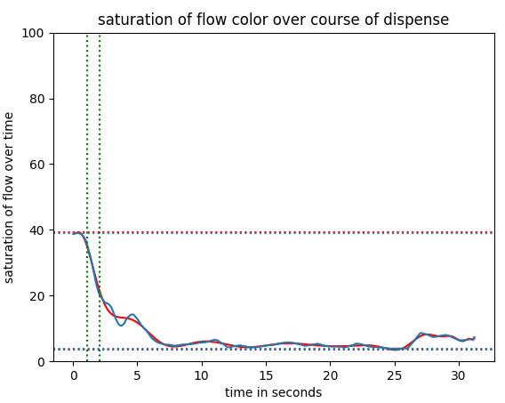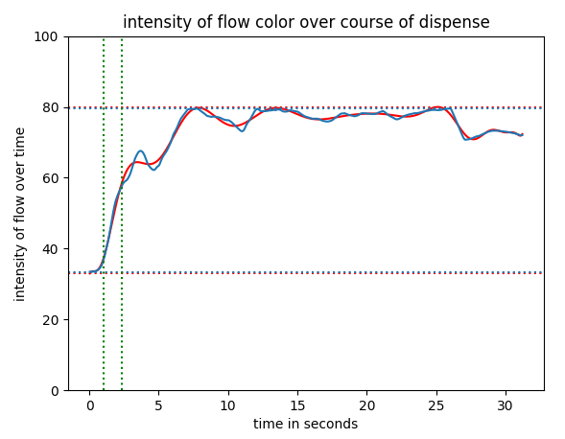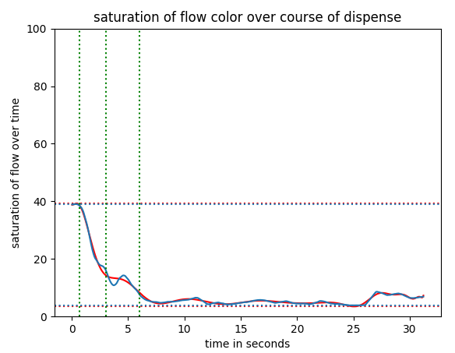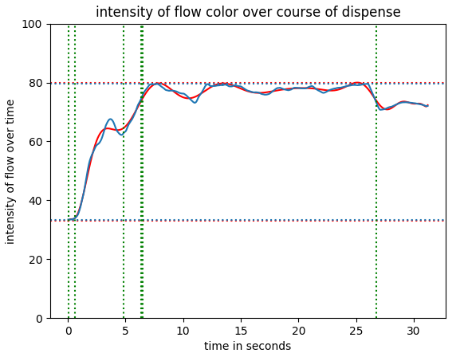
The top two graphs show the divisions of saturation and intensity when the values of the classifier are kept at the standard values (here: 7;4;4). The others, when the values are being scaled down to a way lower value. Way more divisions between colours can be seen in the second row with the exact same graphs.
- Canny Edge Detector
The parameter for the canny edge detector are being used to detect the borders of objects within the image. An example can be seen here:
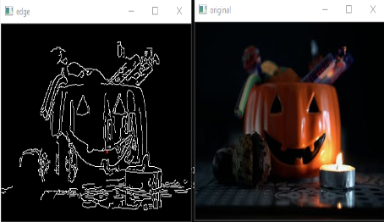
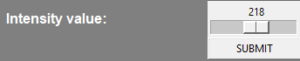
The higher the value is, the stronger the contrast between two colour values has to be, to be considered an edge. If the value is in the lower spectrum, the lower the contrast between colour values needs to be, to be detected as an edge. Sometimes, you want to lower the value of the canny edge detector to detect the object edge better. However, with this, more unwanted edges (e.g. from reflections and light changes) can / will be detected as well. If you are facing too many unwanted edges, increase the border value of the edge detector.
For example, in the picture above, some of the differences in shade and reflections of light are being seen as the edges of the object. If you don’t want that to happen, increase the values.

- ROI
The region of interest (ROI) defines the position and size of the window inside of the frame, that you want to analyse. The values are scaled in pixels. The coordinate system of each picture frame and its ROI is being shown in the figure below:
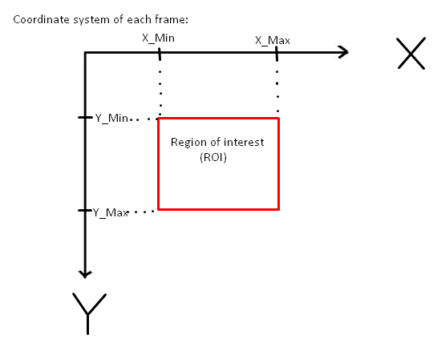
The ROI is the region in which the flow takes place, aka where the stream is going through. The x and y values determine the position and size of the rectangular window. Also note, that within this frame, that there should only be the stream and no other object, whatsoever. This means, that there should be no hand, cup, etc inside this region.

- Analysing the results

The flow width over time should ideally be a straight line during the whole dispense. A perfect reference can be seen in the picture below:
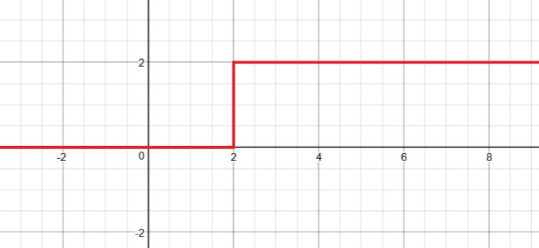
As soon as the flow starts, it should be constant at a certain value over the course of the dispense. A relatively good sample can be seen here:
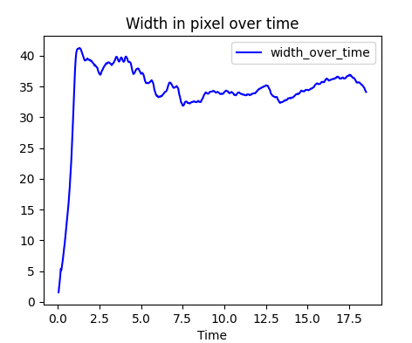
This is the analysis result of the video “Test_16_06_cut”. The flow seems to be relatively consistent around the value 35, with the only exception being the overshoot right at the beginning. A not ideal sample result can be seen here:
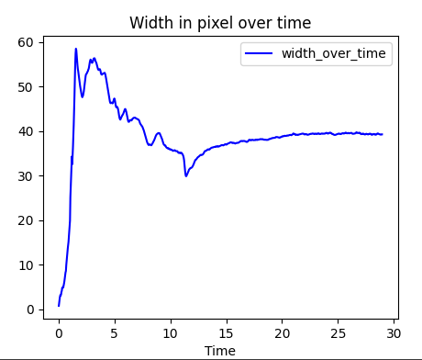
In this sample, the flow starts off strong at the beginning, but quickly gets thinner until about 11 seconds. After that, part of the stream breaks apart from the rest and is just hanging from the opening of the capsule. The breakoff happened because of the too thin stream. In the diagram, we can see the corelation between both events, since the first event follows the second.
The second part of the analysis is the hue, saturation and intensity (colour, saturation, brightness). Ideally, it will stay constantly on one value throughout the whole duration. Any colour change, that is being detected, will be marked via a vertical, green, dotted line. Within two green dotted lines, a colour change is taking place. The average values before and after the colour change can be seen as two respective colours.
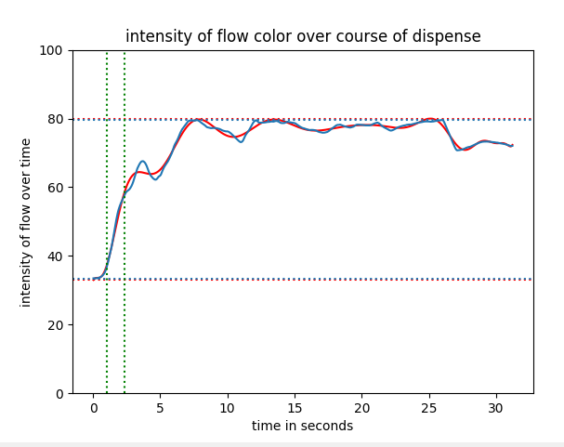

Lastly, every time the analysis program detects a cut off of the flow, a red dotted line will be drawn into the graph, indicating where the cut off has happened. This will also determine, whether the graph is useful at all, if there have been detected too many cut offs.

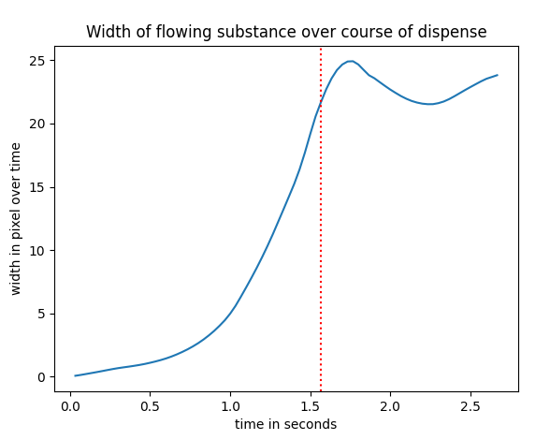

- How to build up the stand
To get a clean video of the stream, have the stand being lit by smooth ambient lighting. This means that the room should not be dark and no spot lights such as from smaller light sources like phone cameras and smaller flashlights should be pointed directly towards the probe stand. Result of too little light will lead to having to tune down the canny edge detector parameters and risking the occurrence of white noise within the video. Pointing spot lights directly at the probe will lead to strong reflections and high contrasts between light and dark parts of the image. This can also lead to unwanted detections, since the edge detector can see contrast in lighting as an edge, too.
Secondly, have a monochromatic background within the planed ROI of your video sample. Recommendations are a green or blue cloth such as these, that are being used for blue screen and green screen effects. These colours naturally have a strong contrast to most of the ice cream colours in the current assortment of flavours (maybe except green tea flavour since it is green).
Finally, watch out for any creases or folds within the cloth background. The background should ideally be completely flat, so that there are no lighting differences within the background. As mentioned before, lighting differences can be accidentally picked up as object edges, which will lead to an inaccurate output.

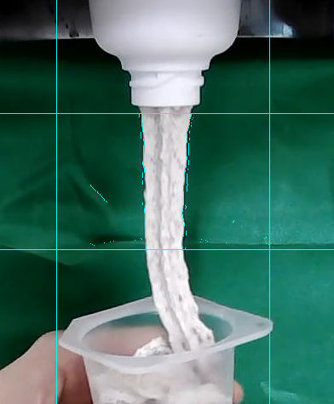
This shows the impact of poor lighting and inconsistent background brightness. The edge detector accidentally mistakes part of the background as parts of the stream.

Sources:
Python OpenCV - Canny() Function - GeeksforGeeks (17.06.22)
Signals - Practical EE (17.06.22)
https://i.stack.imgur.com/PokCt.png (22.03.22)

